**THEME**: Understanding Energy Production & Consumption Trends in Countries|Cities Across The World & Its Relationship With Relative Economic Growth Over the Last Two Decades.

**OUR PROPOSED STRATEGY**:

- Make API calls to the US Department of Energy, world enerdata and other data sources.

- Store our findings in MongoDB

- Analyze data from over 150 countries or 500cities

- Visualize our analysis using HTML & javascript libraries with a minimum of 3views

**DATASET LINKS**

* <https://yearbook.enerdata.net/>
* <https://www.kaggle.com/kingburrito666/residential-energy-consumption-survey>
* [Total International Primary Energy Consumption - dataset by us-doe-gov](https://data.world/us-doe-gov/9c780149-9c05-4773-b60a-e5a15bc49e06)
* <https://www.eere.energy.gov/sled/#/results/elecandgas?city=Topeka&abv=KS&section=electricity&currentState=Kansas&lat=39.0473451&lng=-95.67515759999998>
* <https://www.eia.gov/energyexplained/use-of-energy/commercial-buildings.php>

**INSPIRING VISUALIZATIONS**

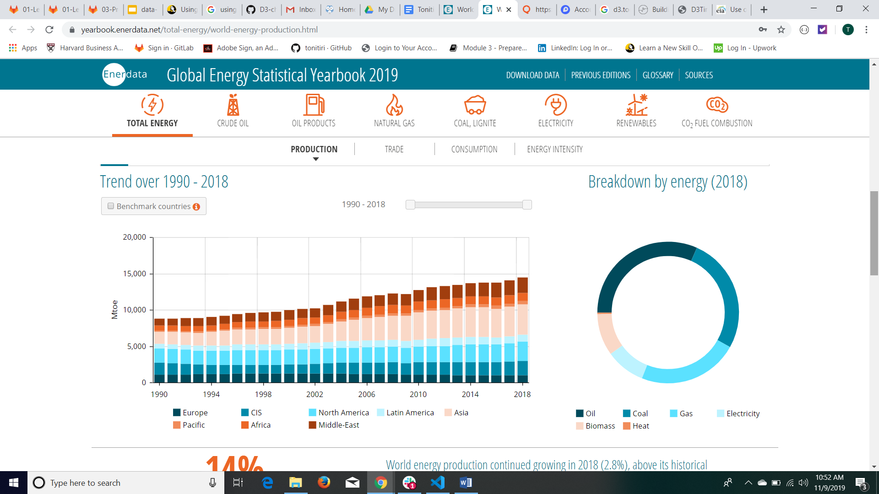

**PRIMARY PROJECT GITHUB REPOSITORY**

<https://github.com/tonitiri/Project2.git>

**OUR ETL STRUCTURE**

Extraction: - CSVs & Json data from energy websites via downloads & API calls

Transformation: - cleaning, filtering & transposing data.

* Converted some data to HTML. (all in enclosed jupyter notebook)

Loading: - Loaded in MongoDb. (jupyter notebook)

Rendering: - Flask App

Visualization: - HTML, Javascript, JS query & Highchart Tables plug-ins.

**GROUP MEMBERS**

* Edward Dorris
* Hailu Sefera
* Taiwo Onitiri